
American International University-Bangladesh (AIUB)
Department of Computer Science
Faculty of Science & Technology (FST)
CAMPUS ROUTE BUDDY
Project Report
Semester: Summer 25-26
Group: __________________ |  | Section: __________________
SL | Student Name | Student ID
1
2
3
4
5

Assessment Rubric
CO1: Explain the impact of software engineering over various contexts of software development to assess societal, health, safety, legal and cultural issues.
Student ID | Problem Analysis [3] | Socio-cultural Impact [3] | Related Solutions and Studies [4]
1.
2.
3.
4.
5.

CO2: Explain software engineering principles considering professional responsibilities and societal impacts.
Student ID | Conceptual Understanding [3] | Principle Selection and Justification [3] | Application in Software Development Context [4]
1.
2.
3.
4.
5.

Table of Contents
1. Project Proposal | 4
1.1 Background to the Problem | 4
1.2 Selection of Process Model | 4
2. Timeline Chart / Gantt Chart | 5
3. Software Requirements Specification (SRS) / PRD | 5
3.1 Scopes and Features | 5
3.2 User Story Table | 7
3.3 Requirements Traceability Matrix | 9
3.3.1 Functional Requirements | 10
3.3.2 Non-Functional Requirements | 13
- Software Design | 14
4.1 System Design | 14
4.2 UI Design With Figma | 15
- Trello Board | 43
- Conclusion | 44

4.2 UI Design using Figma
Siam:
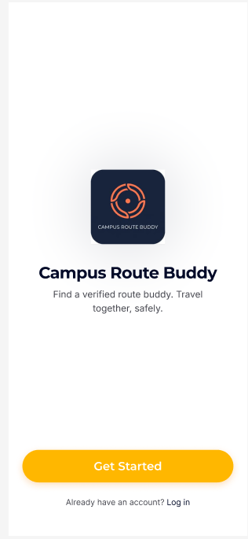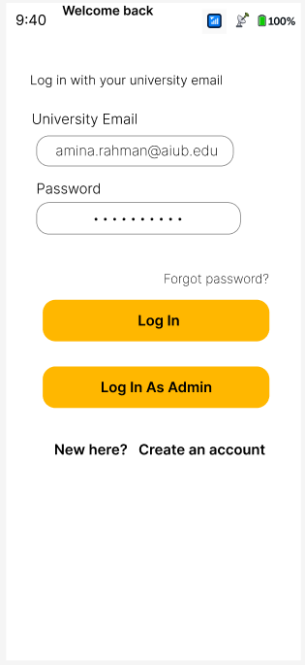
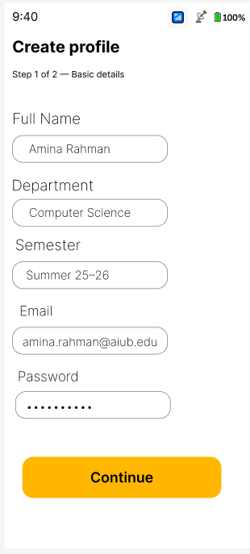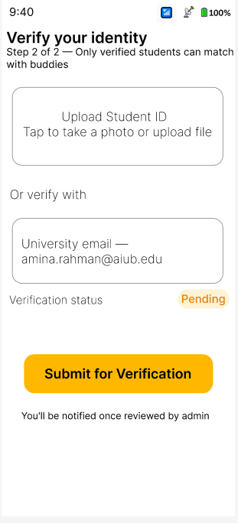
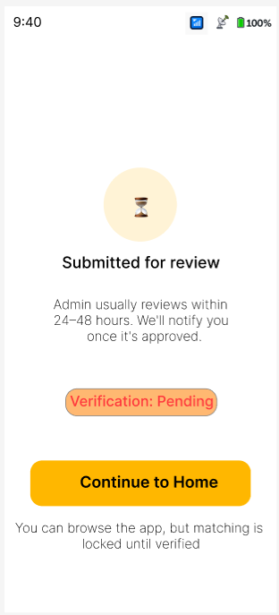

Shuvo :
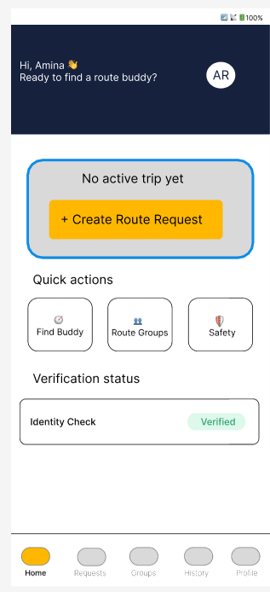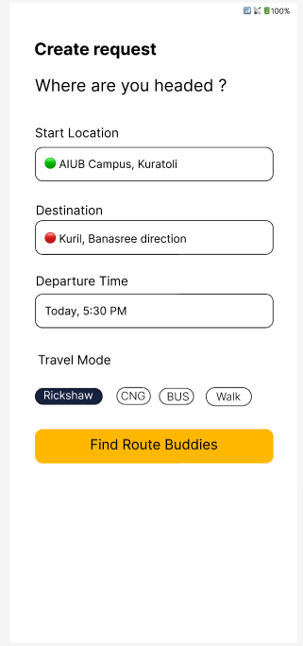
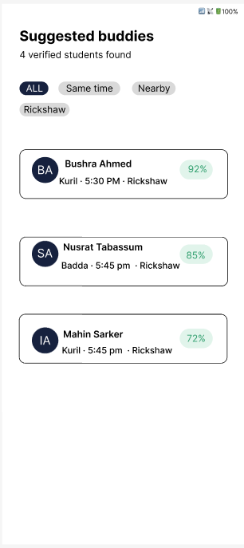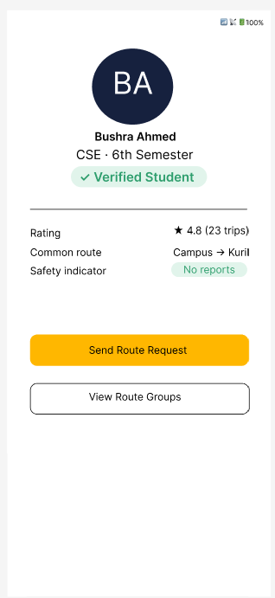
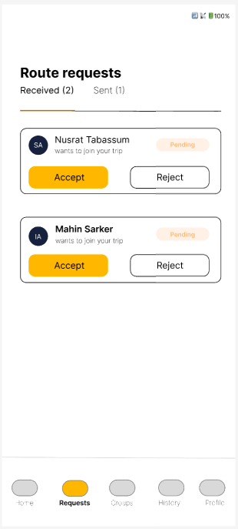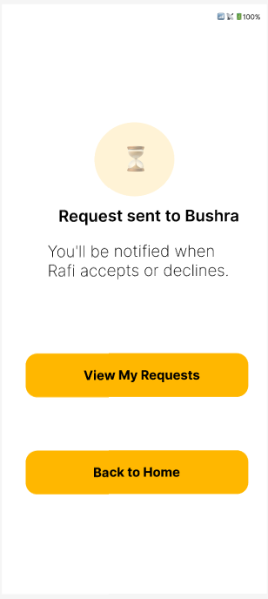

Istiauque :
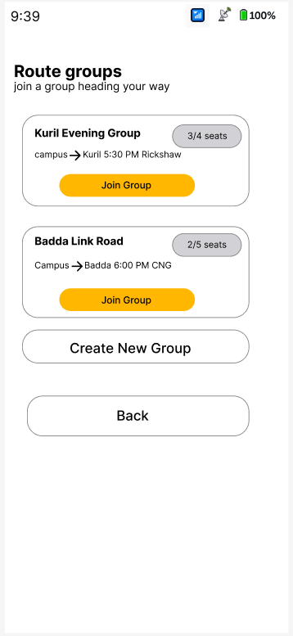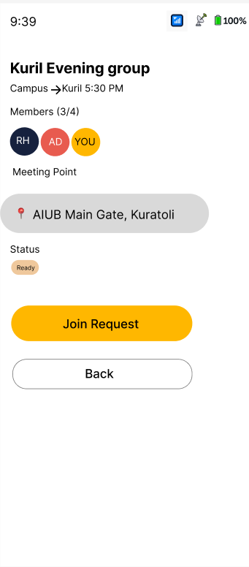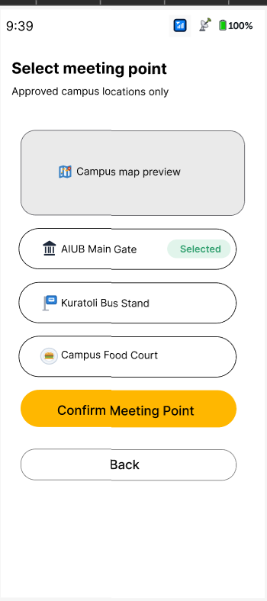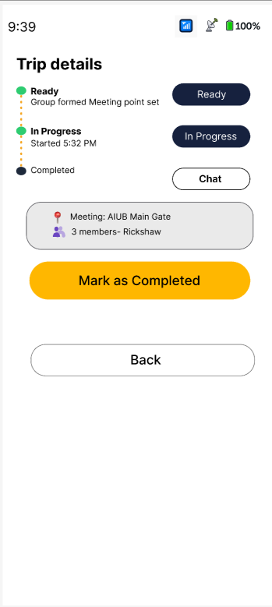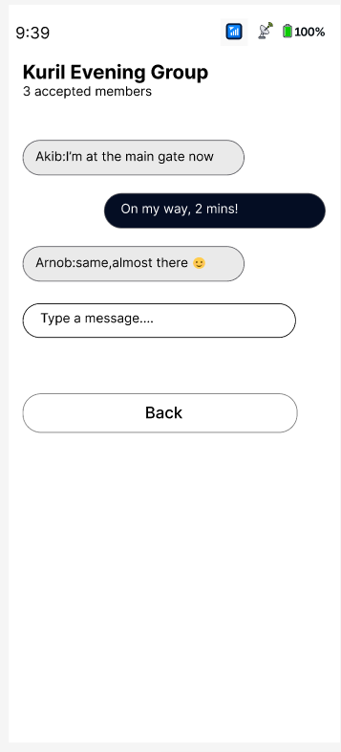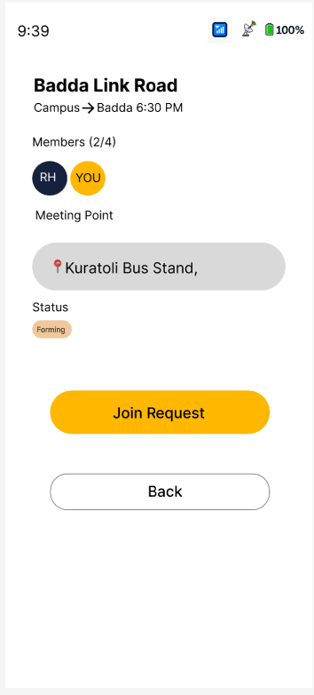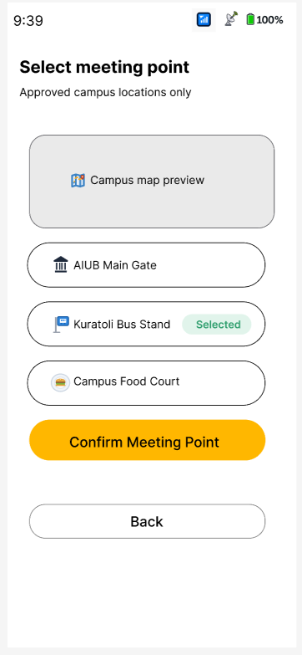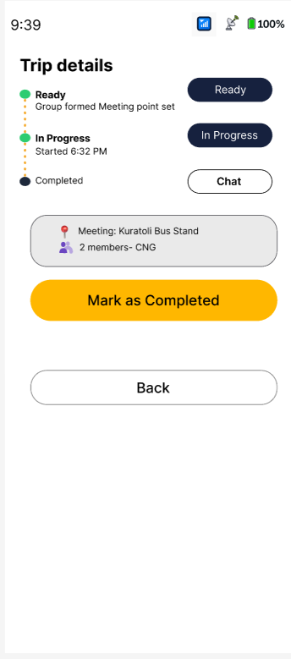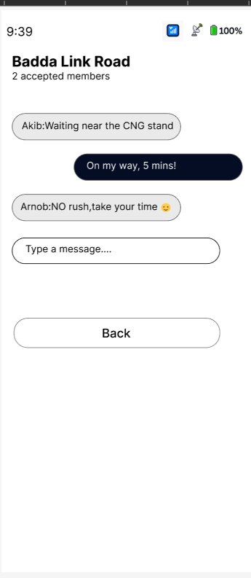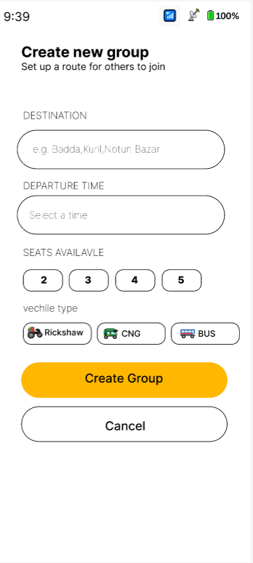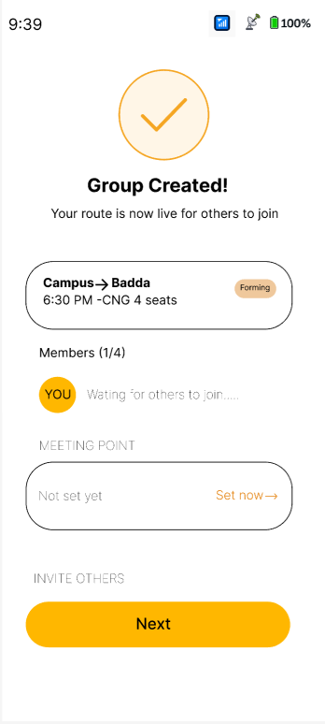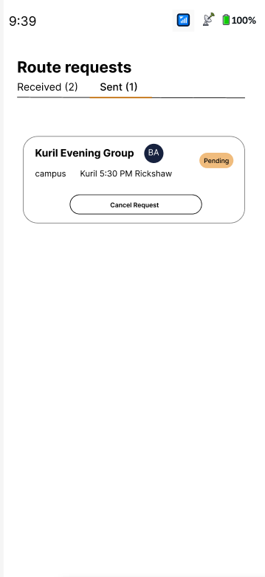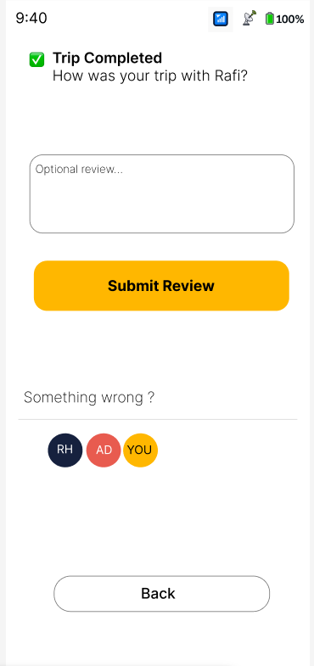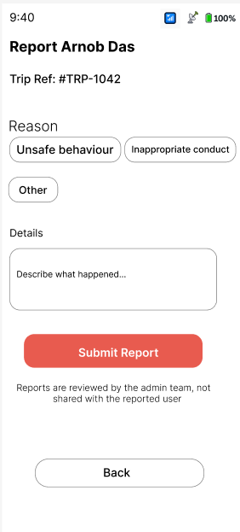

Arnob :
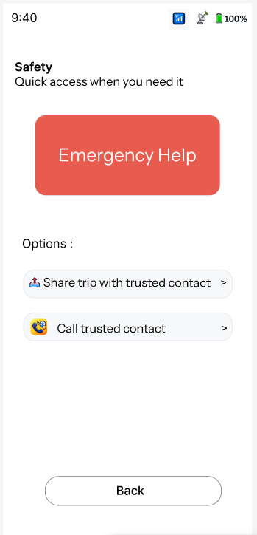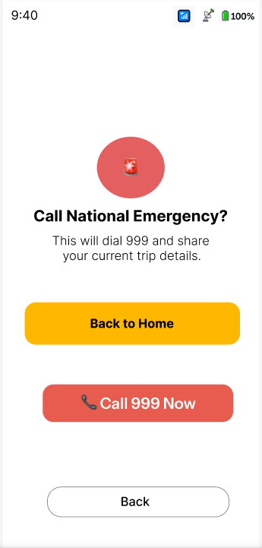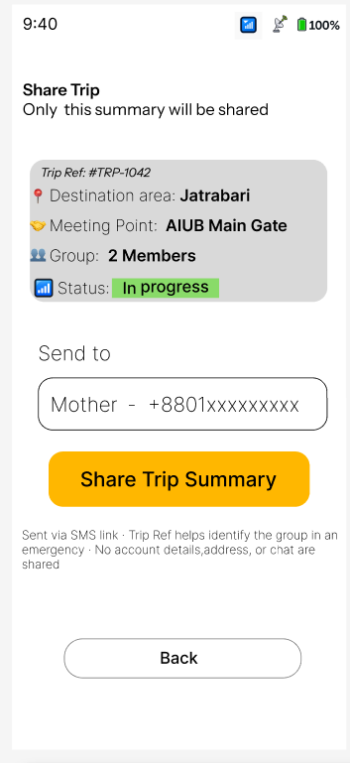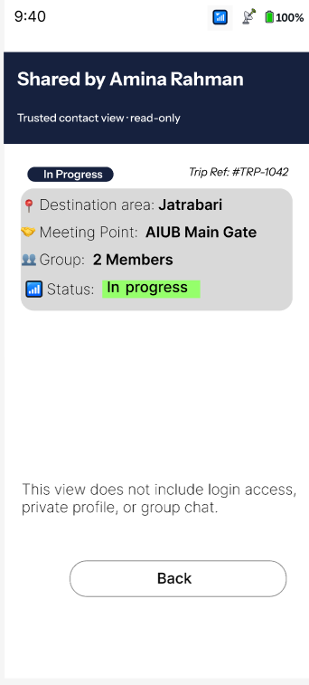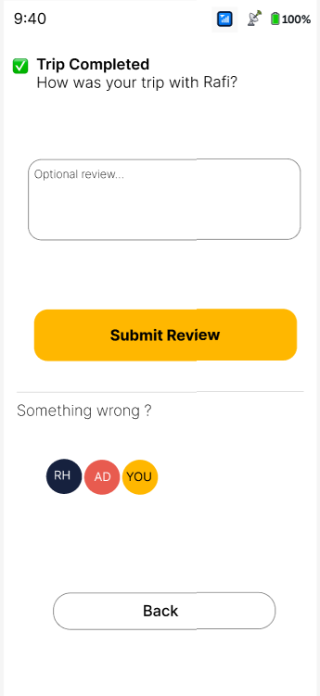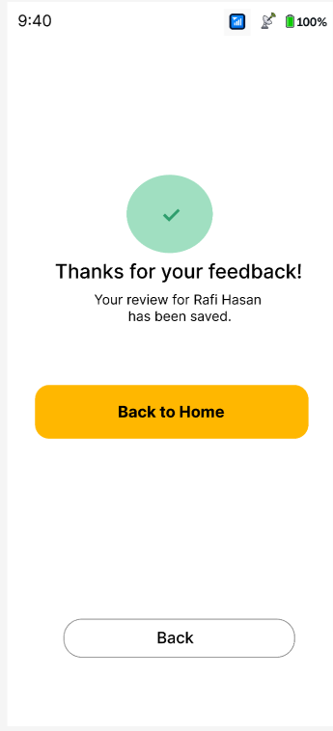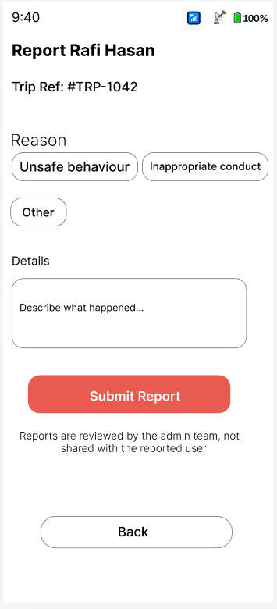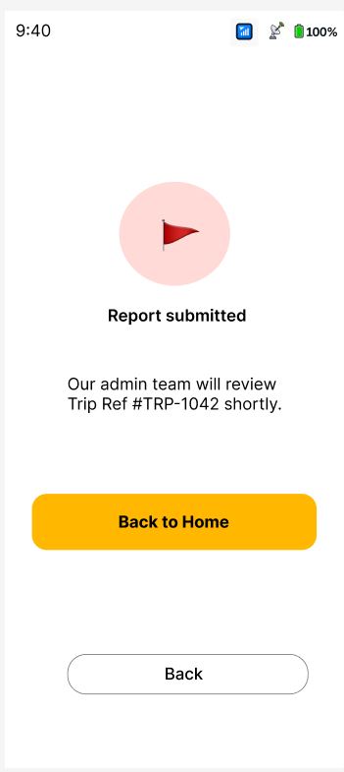
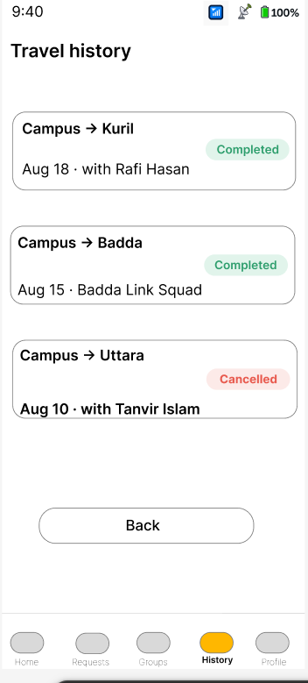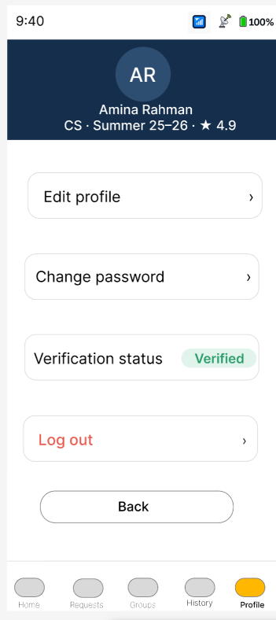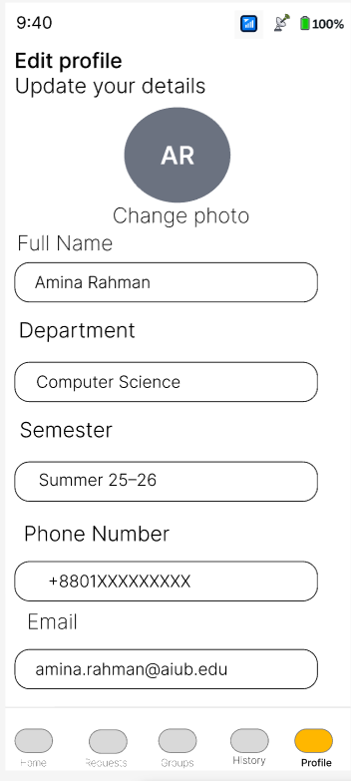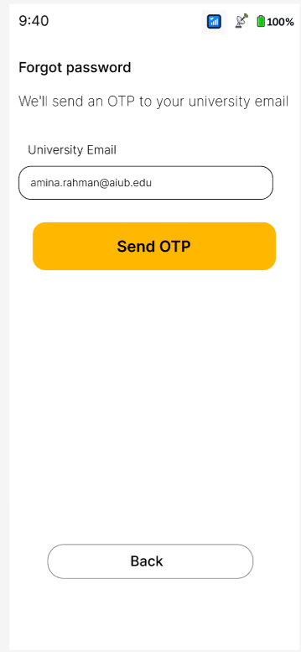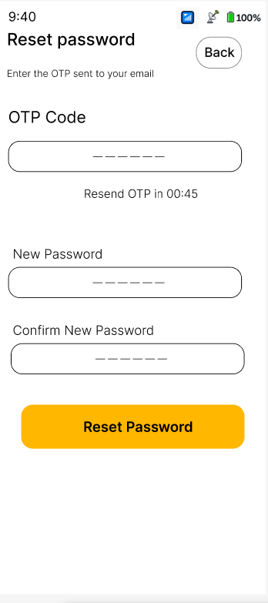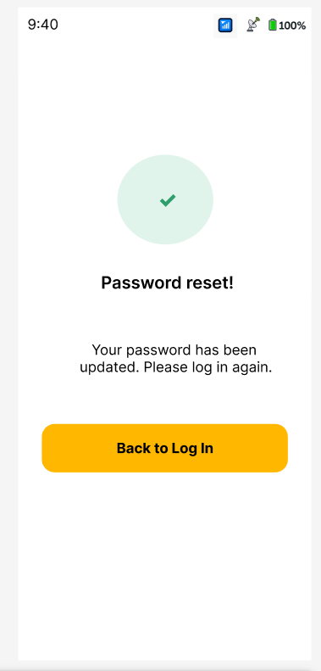

Sabit:
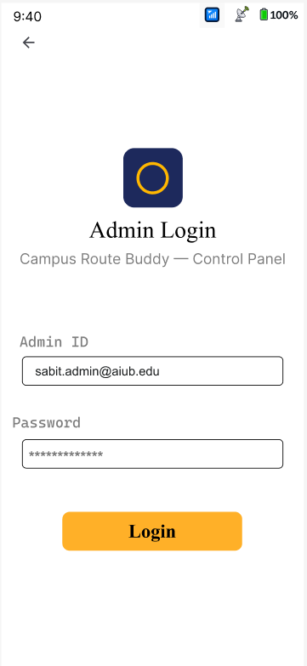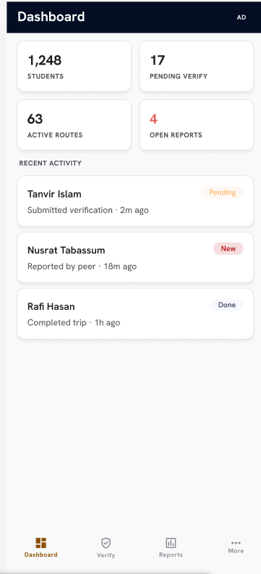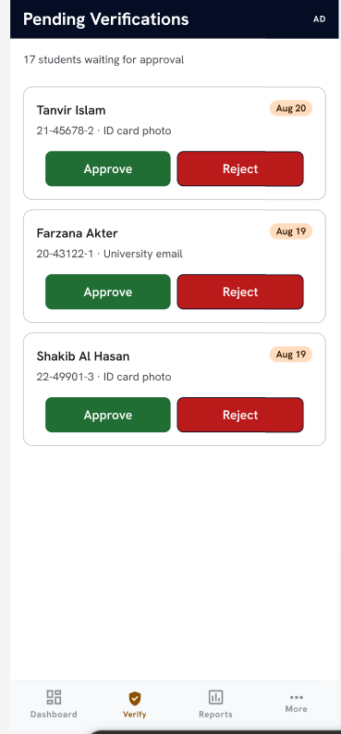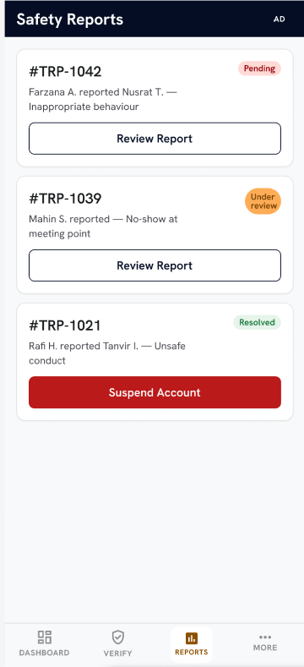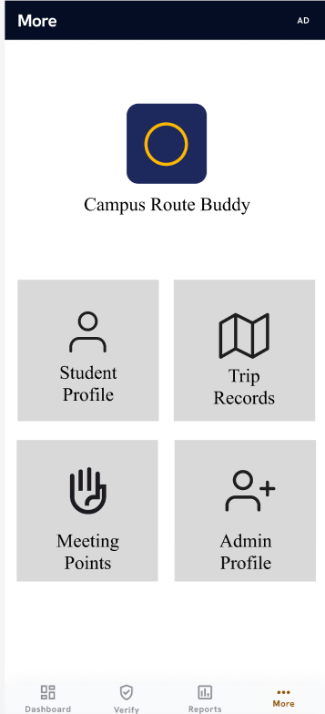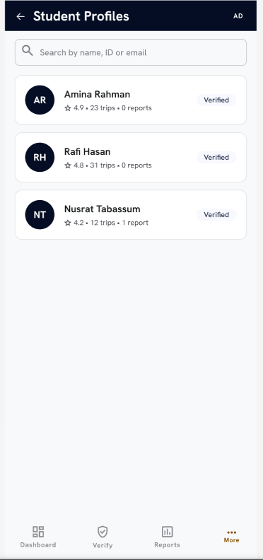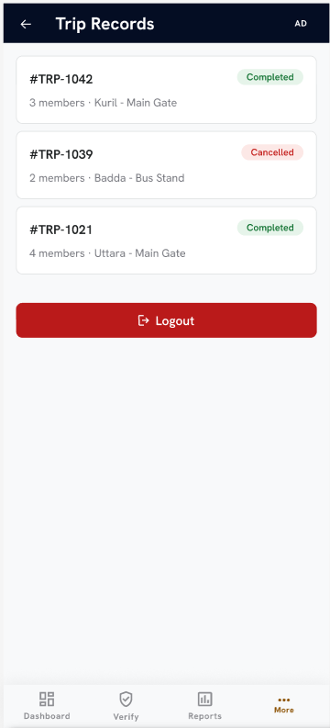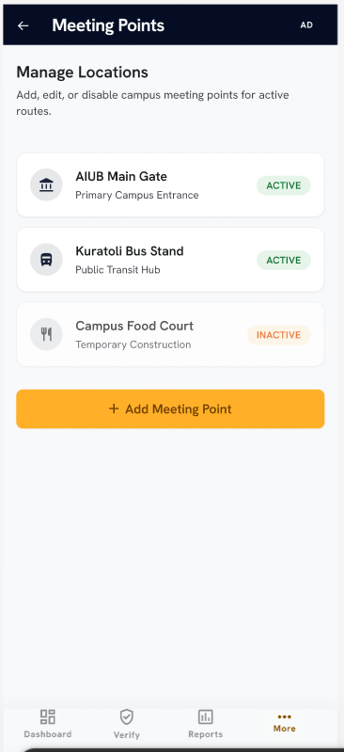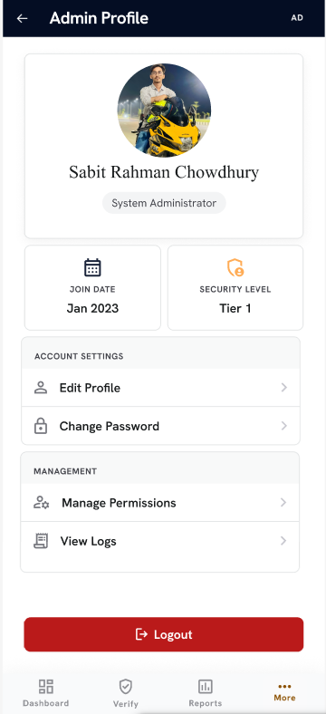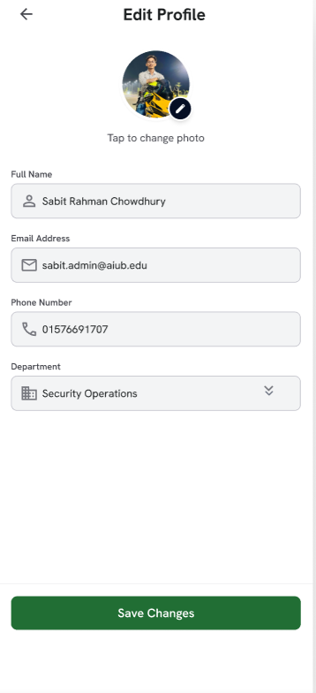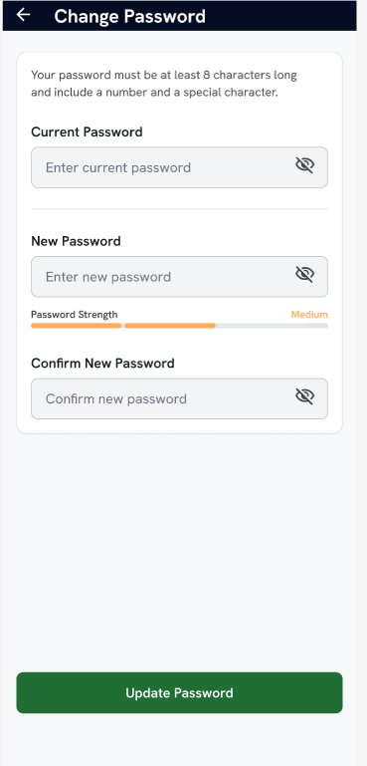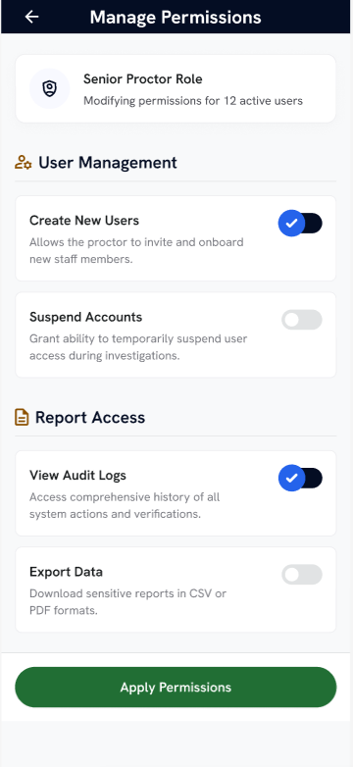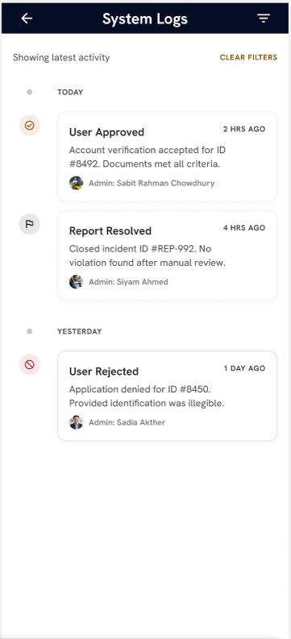
5.Trello Board
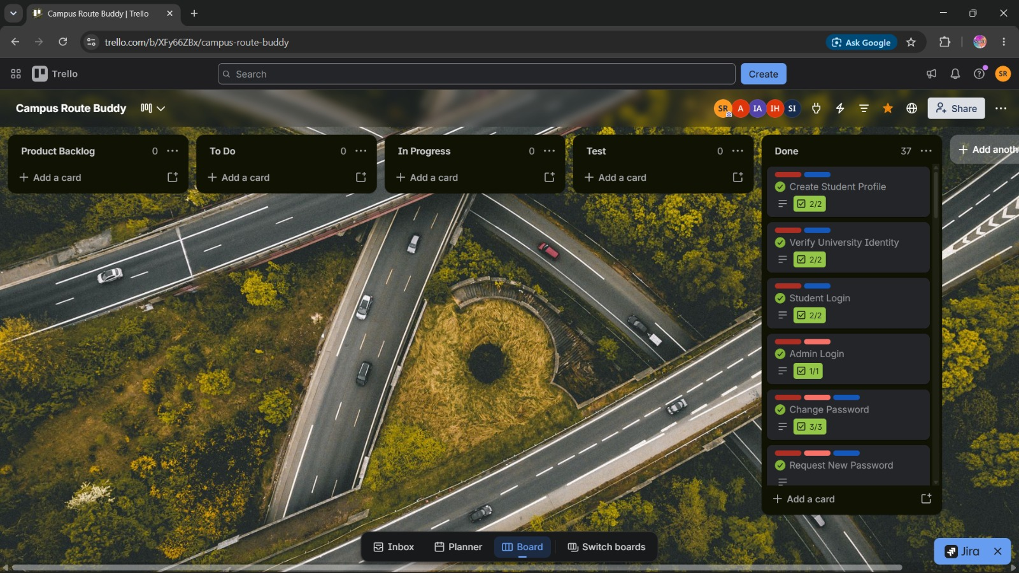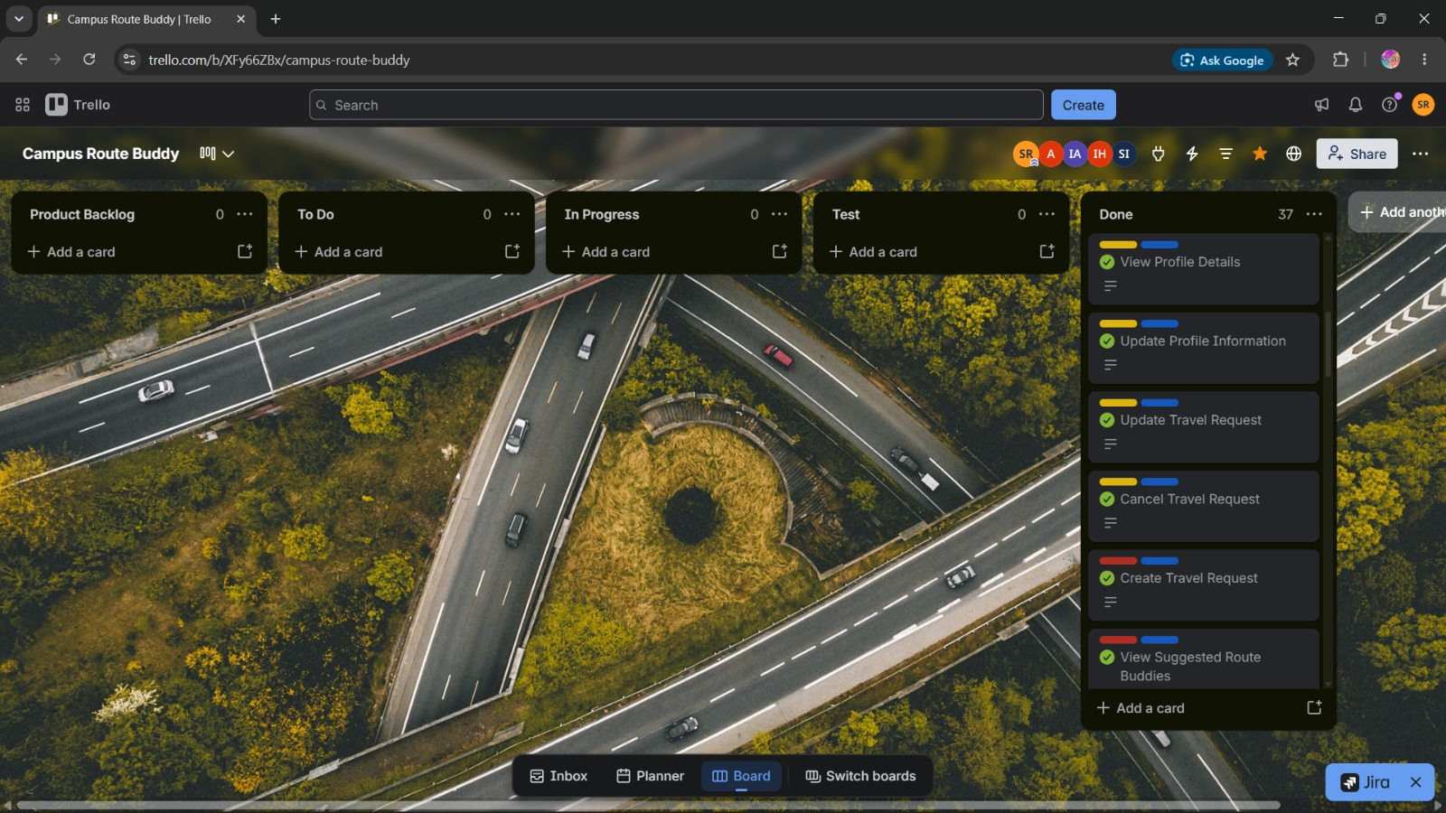

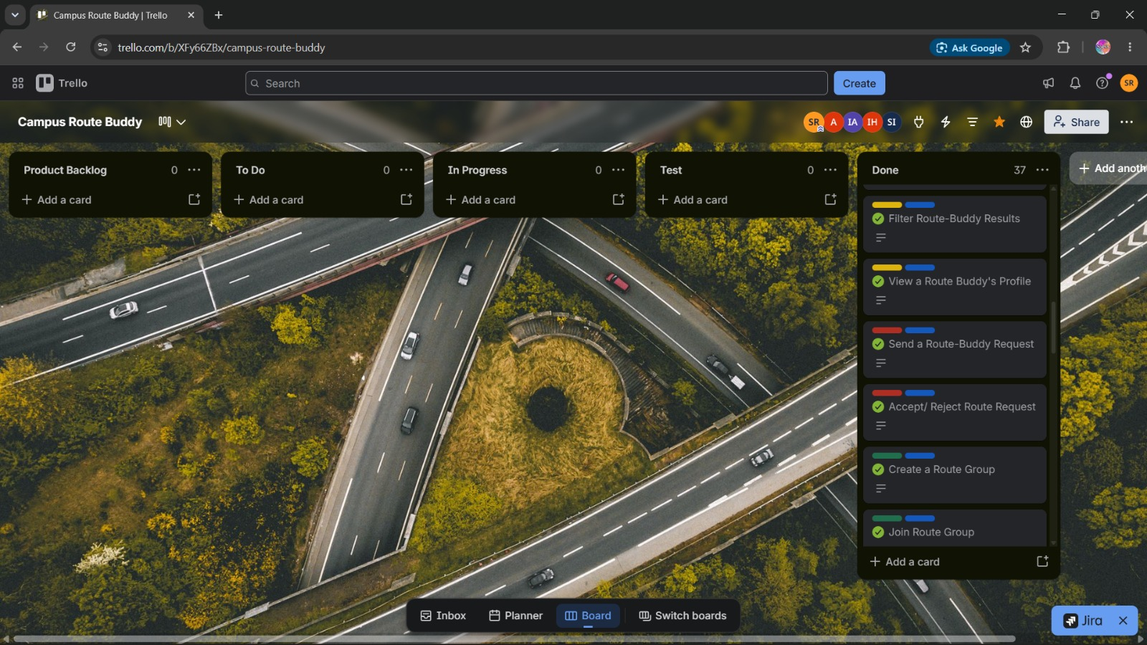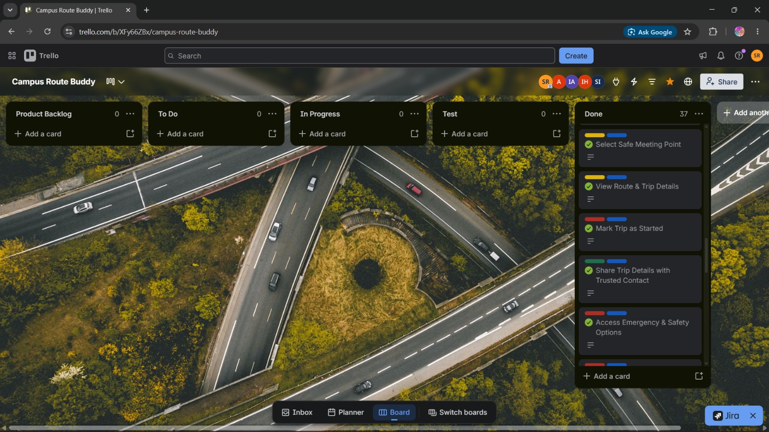

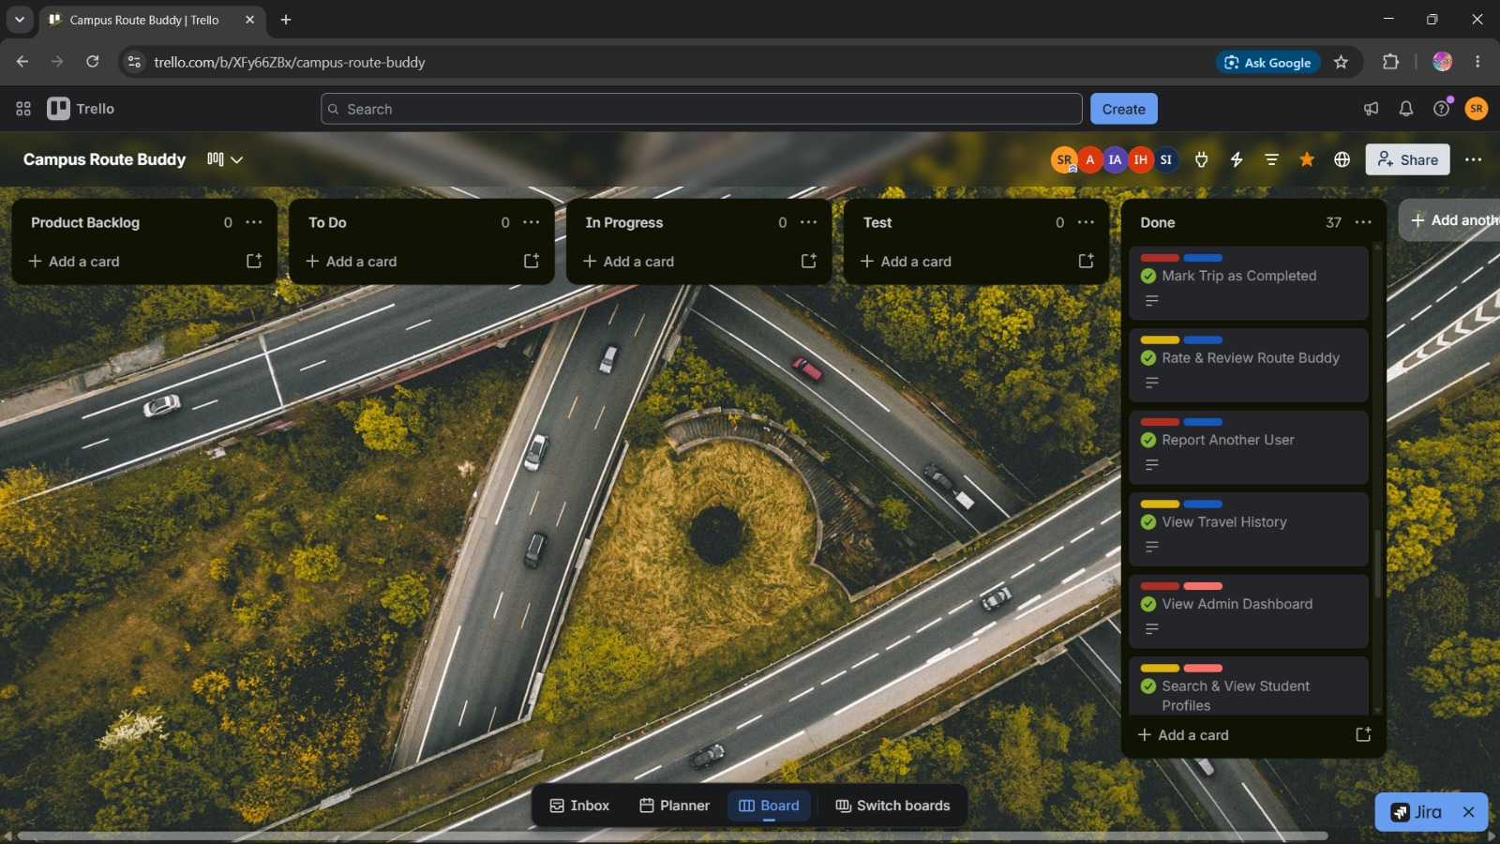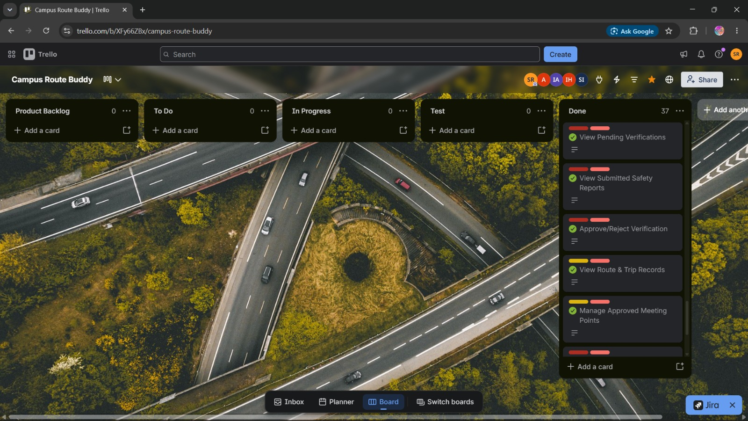
6. CONCLUSION
The Campus Route Buddy project was designed as a student route-matching and safe travel companion system for university students. The main purpose of this project is to help verified students find other students or route groups travelling toward the same or nearby destination. The system focuses on safety, trust, privacy, and organized trip coordination rather than transport cost calculation or payment handling.
Throughout the project, the team applied software engineering concepts such as requirement analysis, user stories, Scrum-based task planning, functional and non-functional requirements, traceability, system design, and UI prototyping. The Figma prototype represents the major user flows, including student registration, university verification, route request creation, suggested buddies, route groups, meeting point selection, trip details, safety options, trusted contact sharing, review, report, and admin management.
The project also considers important ethical and privacy concerns by avoiding public display of exact home addresses and unnecessary personal information. Admin features such as verification management, report handling, account suspension, meeting point management, permissions, and system logs support better control and safety.
Overall, Campus Route Buddy provides a practical and student-focused solution that can improve safe travel coordination within a university environment.

